## Introduction

The Aspen Sliding Joystick is a small analog gaming joystick that moves in a sliding motion instead of the typical pivoting motion of a joystick or thumbstick. It has a relatively small range of motion and a moderately low force required. It has a 3.5 mm TRRS plug (the size of a headphone jack) and can be used with the Forest Joystick Mouse Hub, the Xbox Adaptive Controller (XAC) or PlayStation Access Controller.

## Features

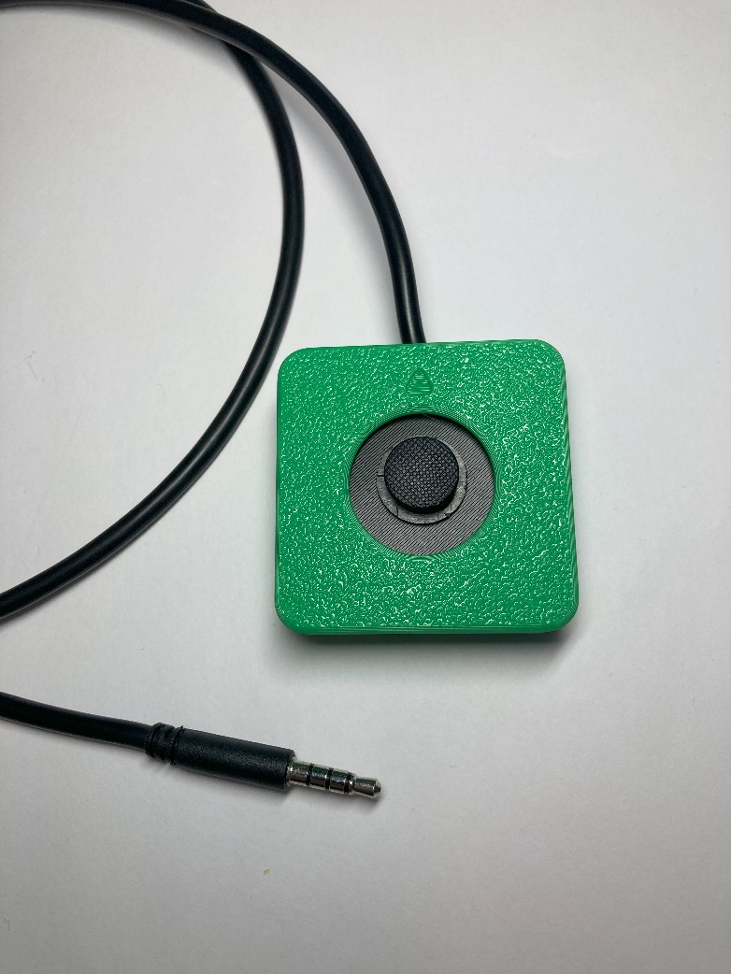

Arrow indicating “up” direction on joystick

Interchangeable joystick toppers

3.5 mm TRRS cable

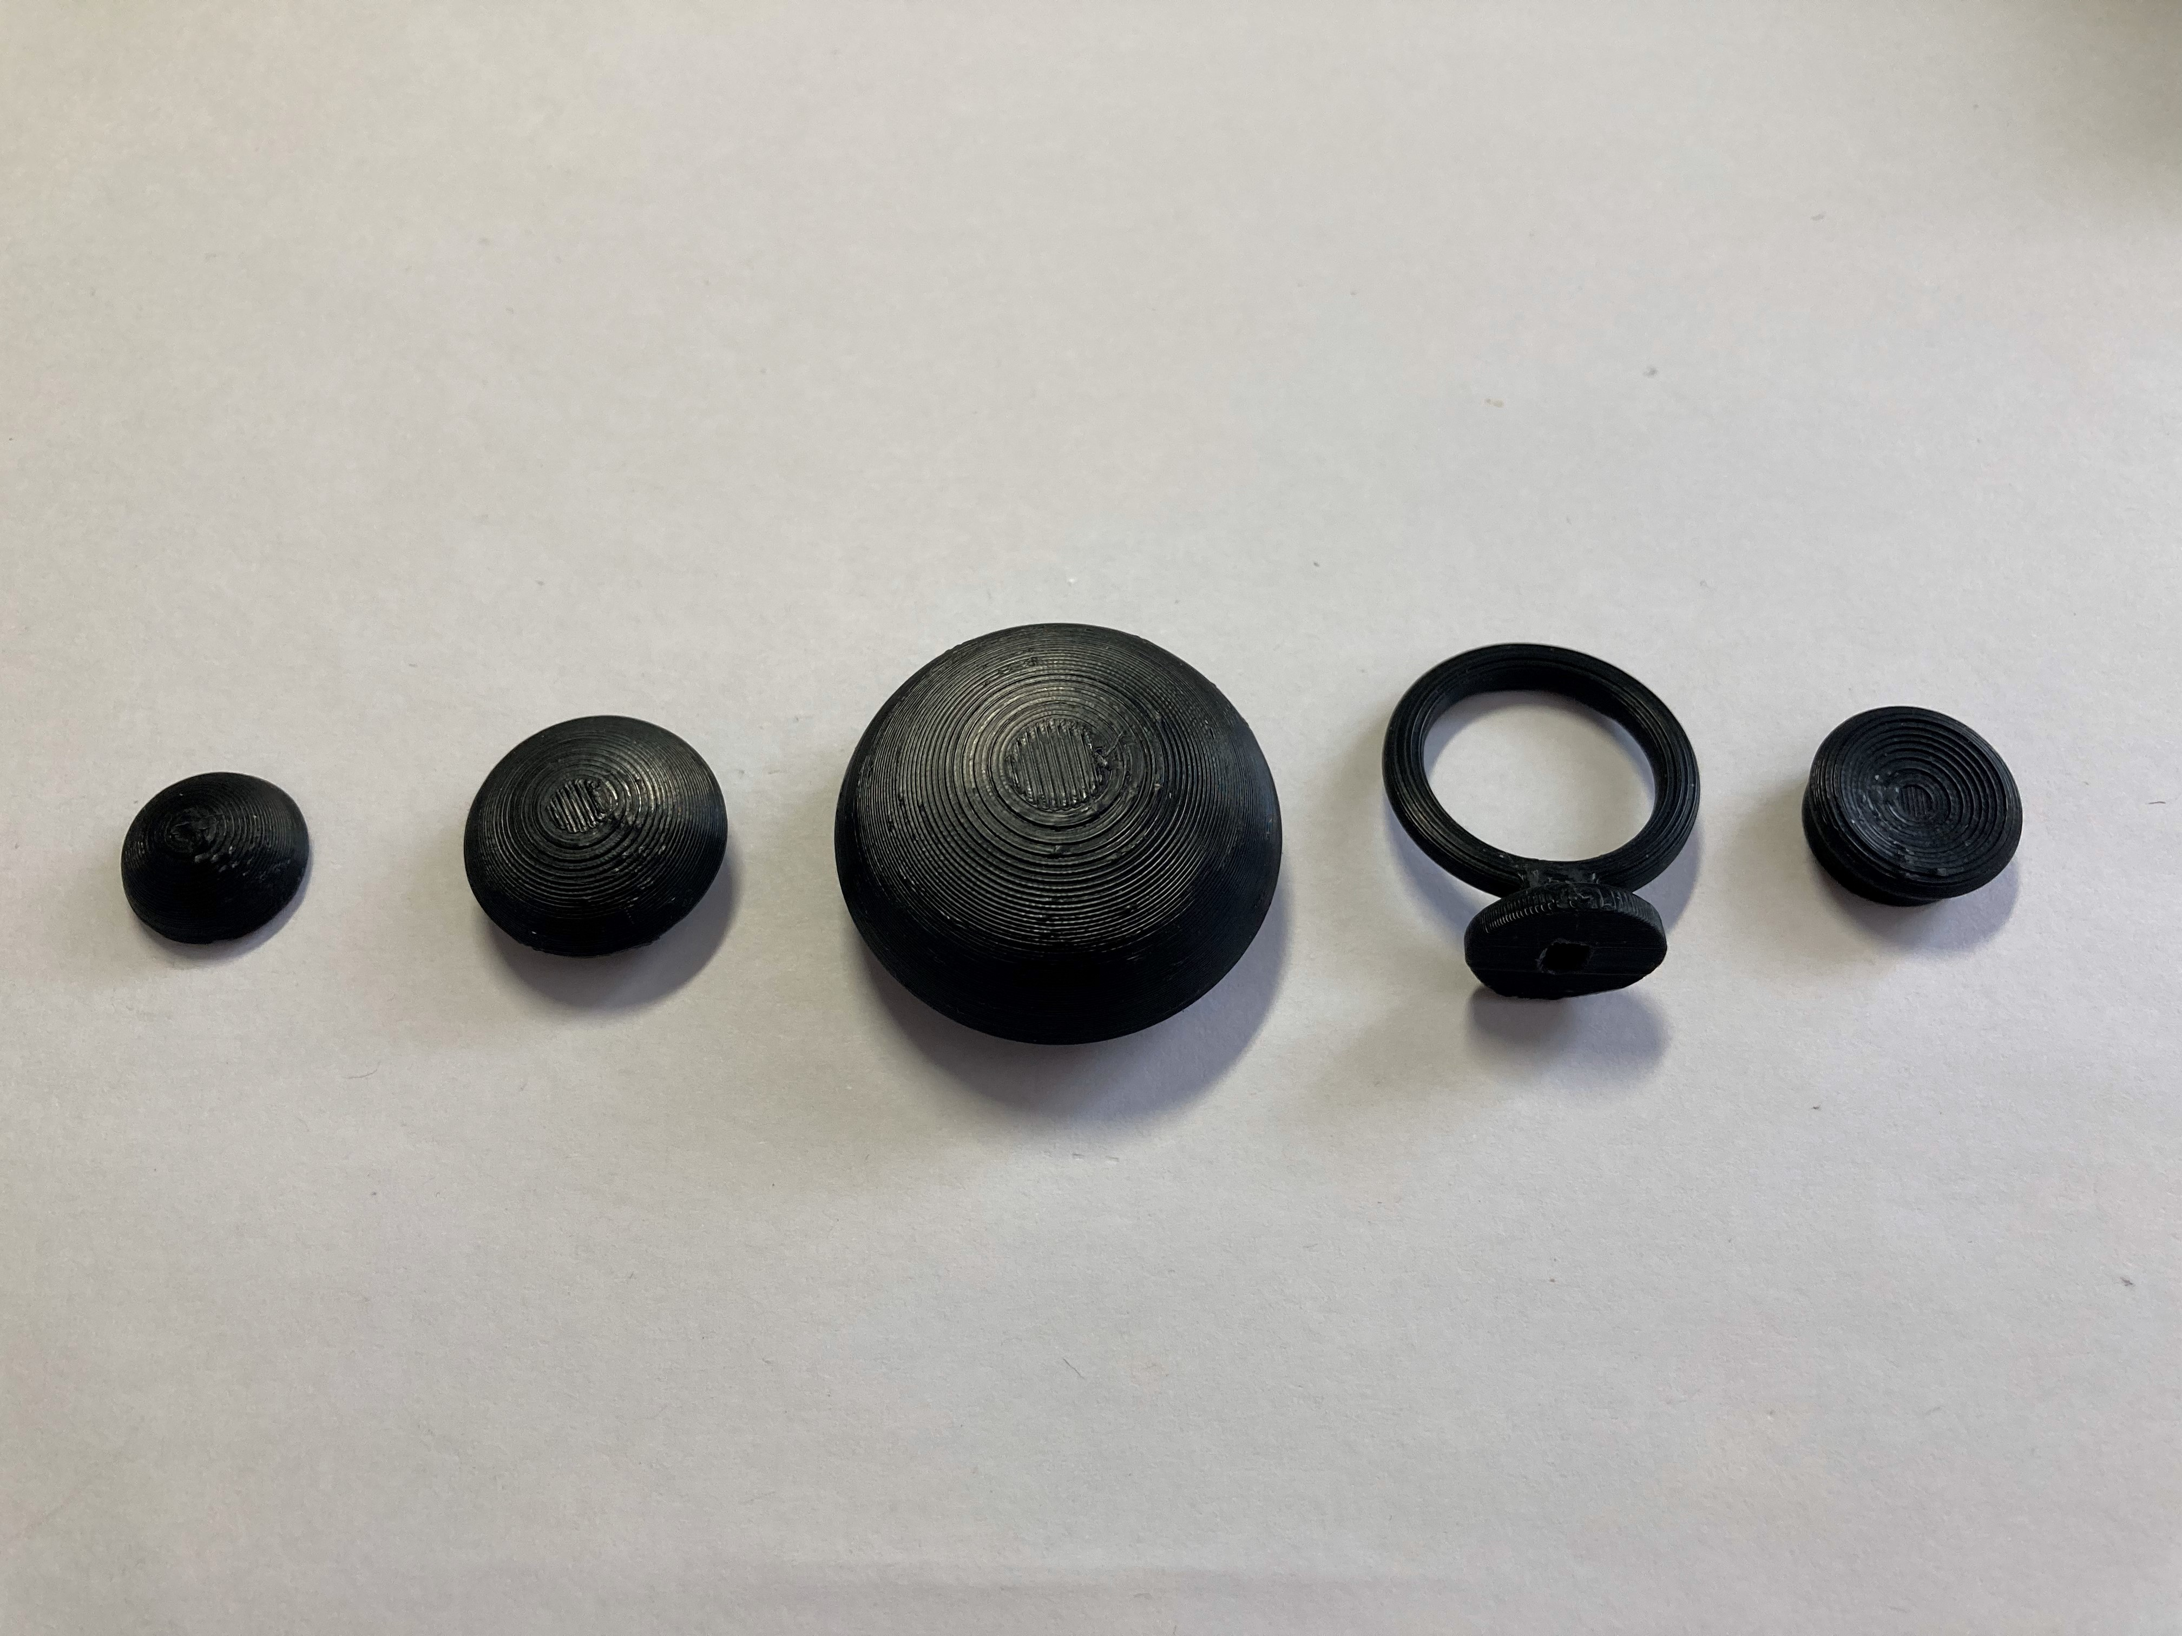

### Mounting holes

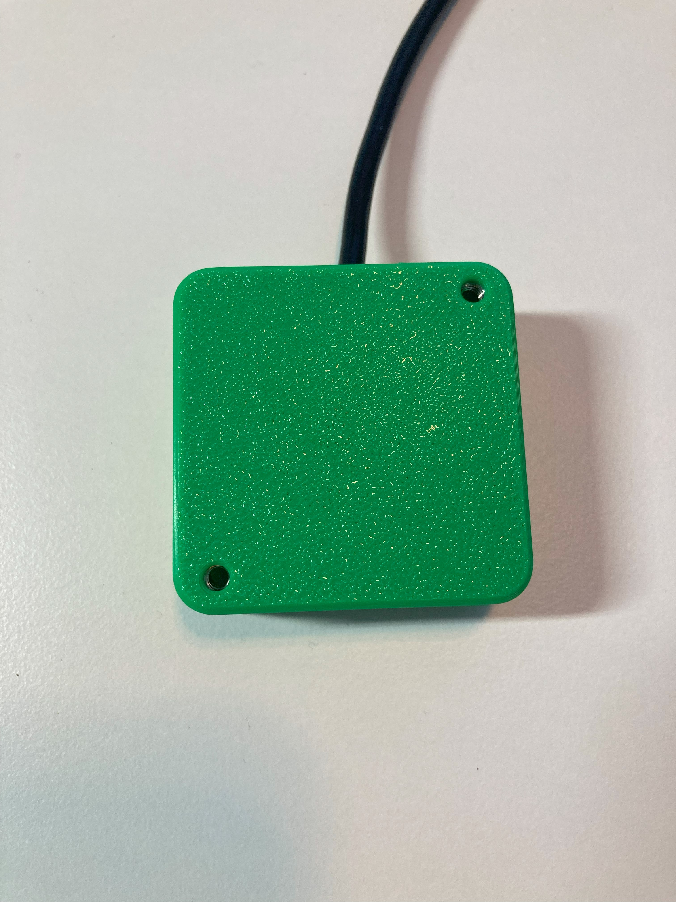

Screw holes for mount adapters

## Usage

### Compatibility

The Aspen Sliding Joystick is compatible with the Forest Joystick Mouse Hub, Xbox Adaptive Controller (XAC) and PlayStation Access Controller. It may be compatible with other interfaces that use joysticks with 3.5 mm TRRS cables, such as the [Enabled Controller](https://makersmakingchange.com/project/enabled-controller/).

### Using the Joystick

1. Plug the 3.5 mm TRRS cable from the joystick into the compatible host device. If using the Xbox Adaptive Controller, plug it into X1 to use at the left joystick, or plug into X2 to use as the right joystick.
2. Ensure the arrow on the joystick is pointing in the “up/forward” direction, away from the user.
3. Mount the device if needed (see below).
4. Move joystick as you would with a standard controller.

### Changing the Joystick Topper

There are a variety of toppers that can be 3D printed for this joystick, shown below. These toppers will work on either the Aspen Sliding Joystick or the Birch Sliding Joystick



To use them:

1. Remove the original joystick topper by pulling it off, revealing a small peg underneath
2. Take the 3D printed topper, check that it is in the correct orientation and press it onto the joystick. The fit should be snug.

### Mounting the Joystick

The Aspen Sliding Joystick can be mounted in a variety of ways, primarily either on a tabletop or other surface, or by using a mount adapter with a mounting system. For tabletop or lap tray use, the joystick can be secured using hook and loop fasteners, or a non slip material such as non slip stoppers. For use with a mounting system there are mount adapters for either a ¼-20 threaded camera mount or a RAM mount system.

#### Tabletop – Hook and Loop Fastener

|  |  |
| --- | --- |
| One way the joystick can be mounted, is on a tabletop or other surface such as a lap tray, and fastened using a hook and loop fastener such as Velcro.  Typically, best practice is to stick the side with the loops (the softer side) to the tabletop or other surface, and to stick the side with the hooks (rough side) to the joystick. |  |

#### Tabletop – Non slip pads

Another way the joystick can be use on the tabletop is by using a non slip material, such as the no slip stoppers shown below, or a non slip material such as Dycem.

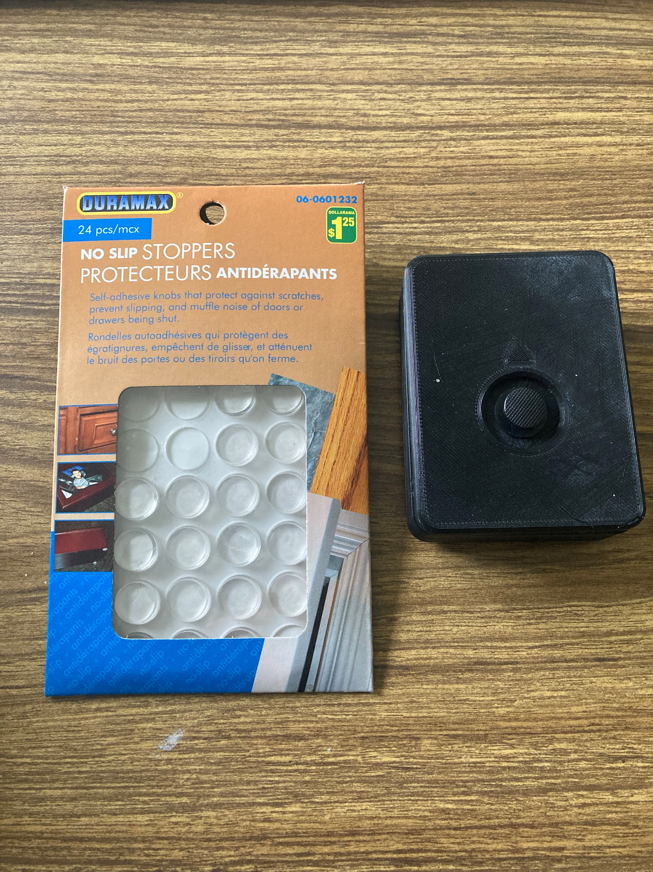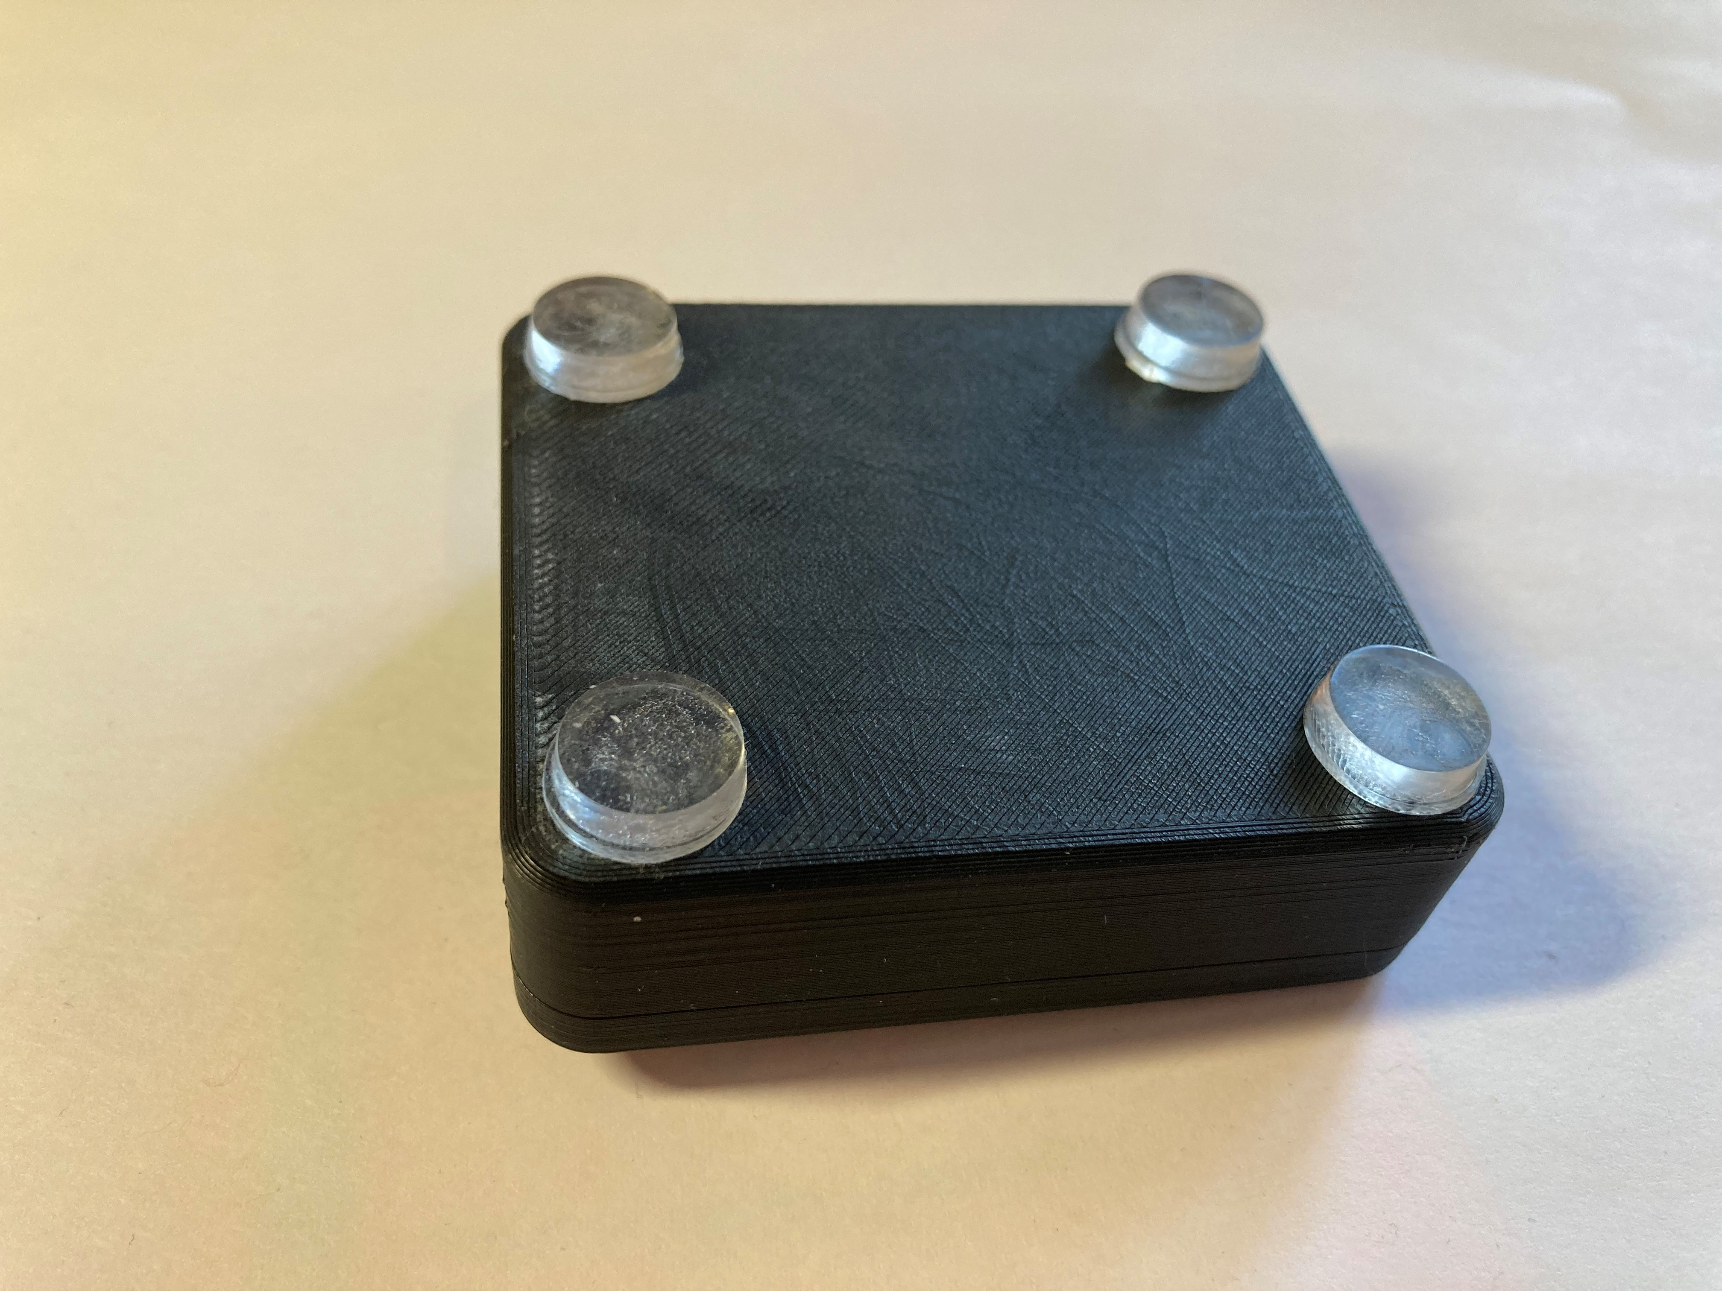

#### ¼-20 Threaded Camera Mount

Another way the joystick can be mounted is by using a mount with a ¼-20 thread on the end, such as a commercially available camera mount. To mount the joystick on a ¼-20 thread, the Camera Mount Adapter is used. The assembly for this Camera Mount Adapter is found in the Maker Guide.

Camera Mount Adapter:

¼-20 thread for camera mount

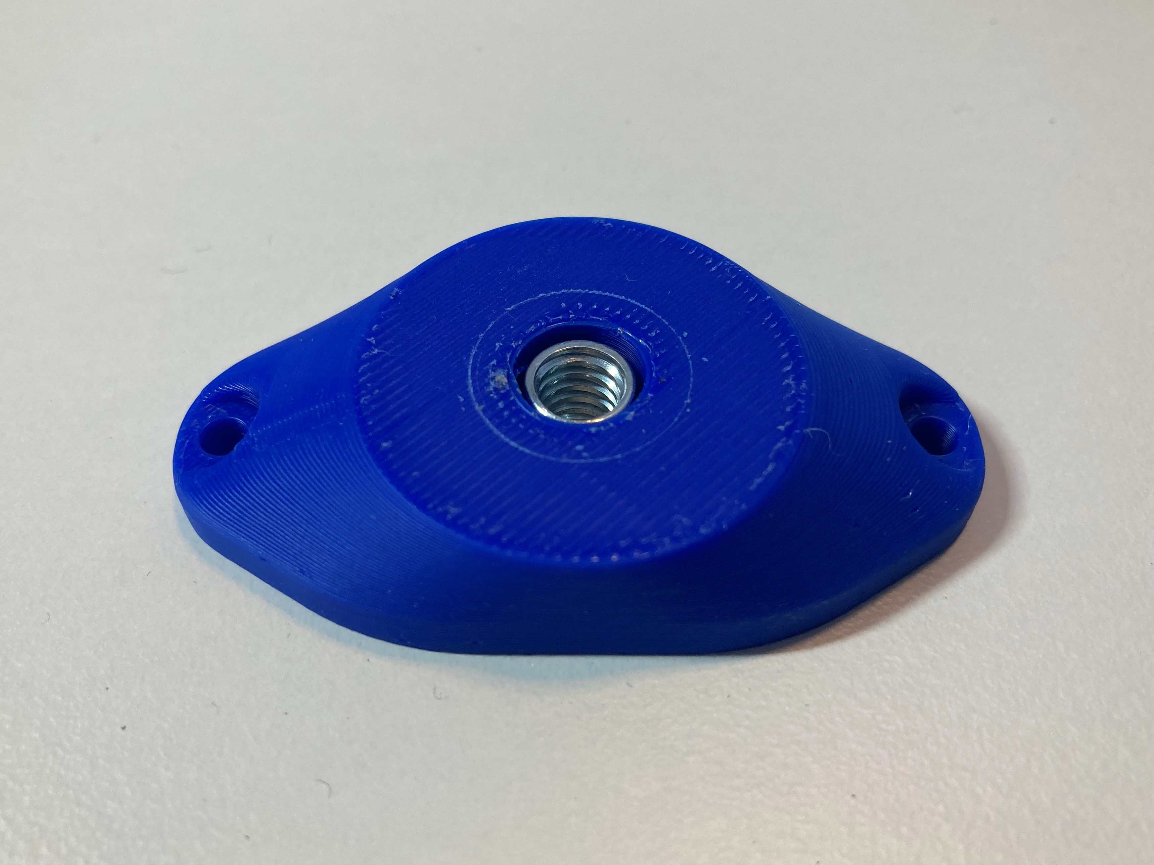

Screw holes to attach to joystick

|  |  |
| --- | --- |
| This is then screwed onto the bottom of the joystick, as shown here, using two M3 screws that are at least 10 mm long. Now, the joystick can be mounted on a mount with ¼-20 thread, such as a typical camera mount. | Green Aspen Sliding Joystick with dark blue camera mount adapter. |

#### RAM B Mount

Another way the joystick can be mounted is by using a commercially available RAM B compatible mount with a 1” ball and socket system. For this, the Joystick RAM Mount Adapter is used.

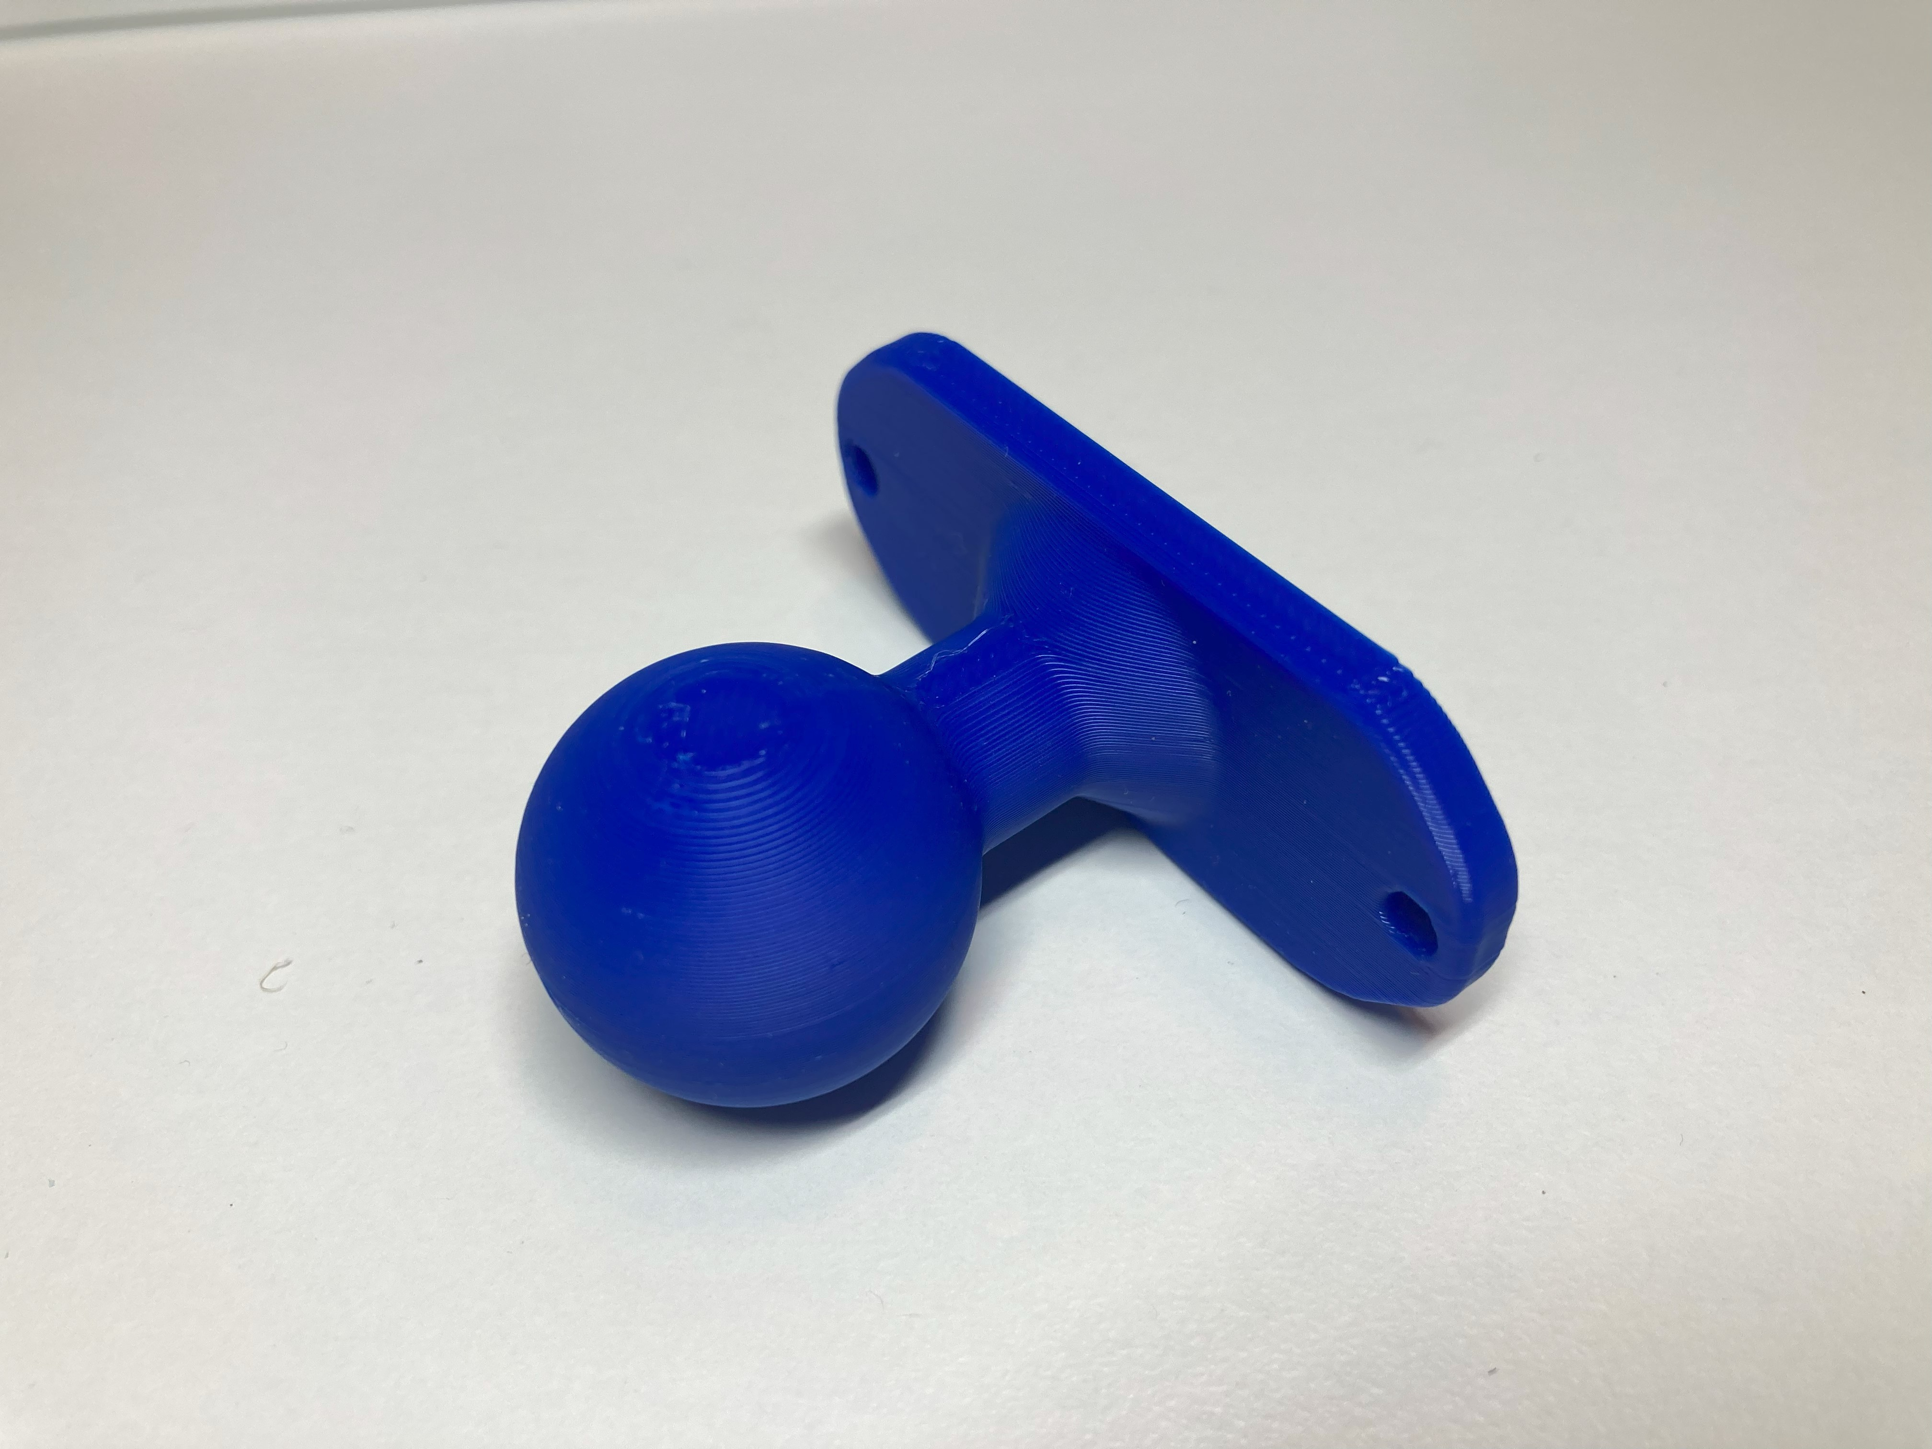 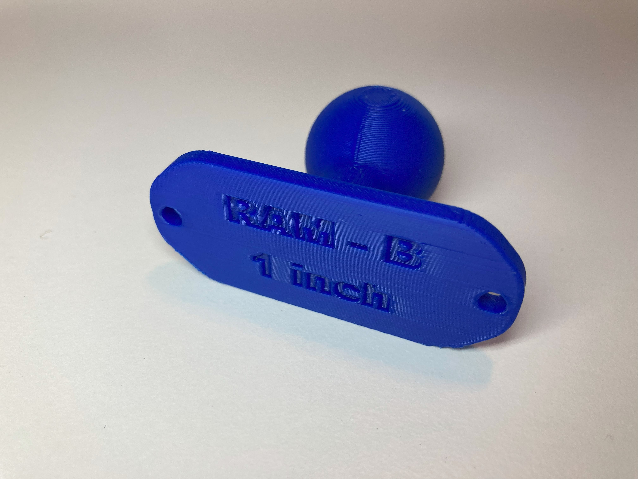

Screw holes to attach to joystick

|  |  |  |
| --- | --- | --- |
| This is then screwed onto the bottom of the joystick, as shown here, using two M3 screws that are at least 10 mm long. Now, the joystick can be mounted RAM B Compatible Mounting System. |  |  |

## Specifications

|  |  |
| --- | --- |
| Total height (with default topper) | 1.9 cm |
| Enclosure height | 1.6 cm |
| Enclosure width | 4.5 cm |
| Enclosure length | 4.5 cm |
| Weight (including TRRS cable) | 40 grams |
| Range of motion | ±2 mm |
| Activation force (to full deflection) | 115 grams of force |

## Cleaning

The Aspen Sliding Joystick can be wiped down with a damp cloth. Do not use hot water on this device or the plastic housing may warp. Do not submerge the device.